CS 255 System Design Document Template

UML Diagrams

UML Use Case Diagram
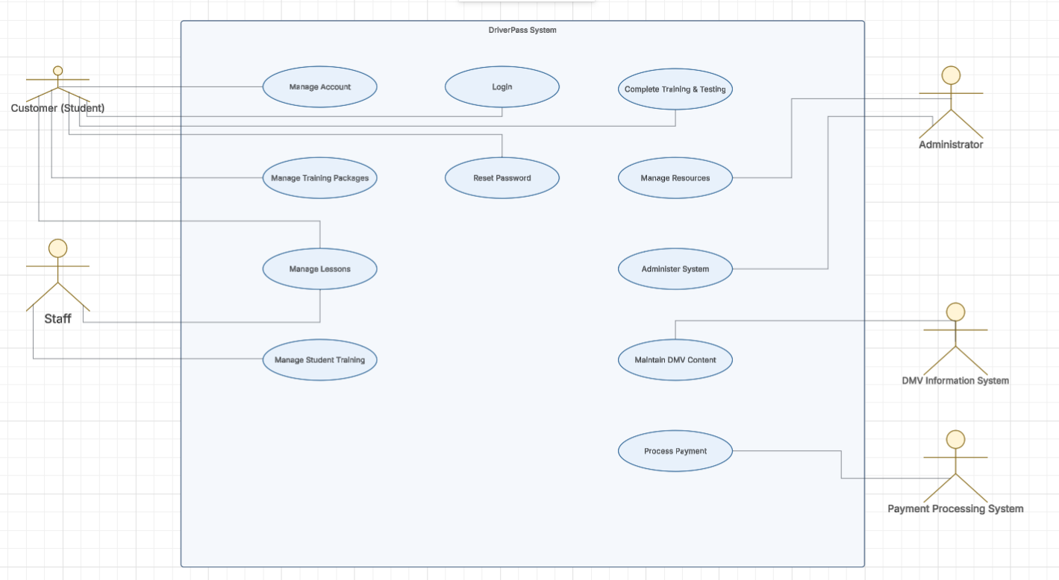

UML Activity Diagrams
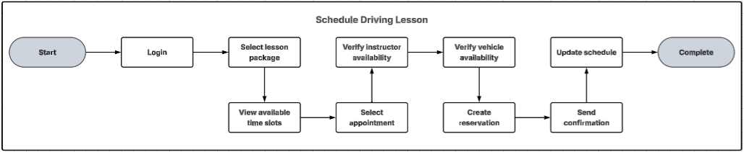

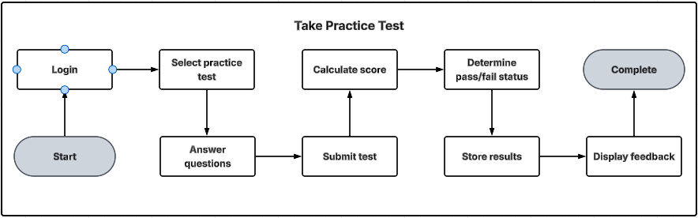

UML Sequence Diagram
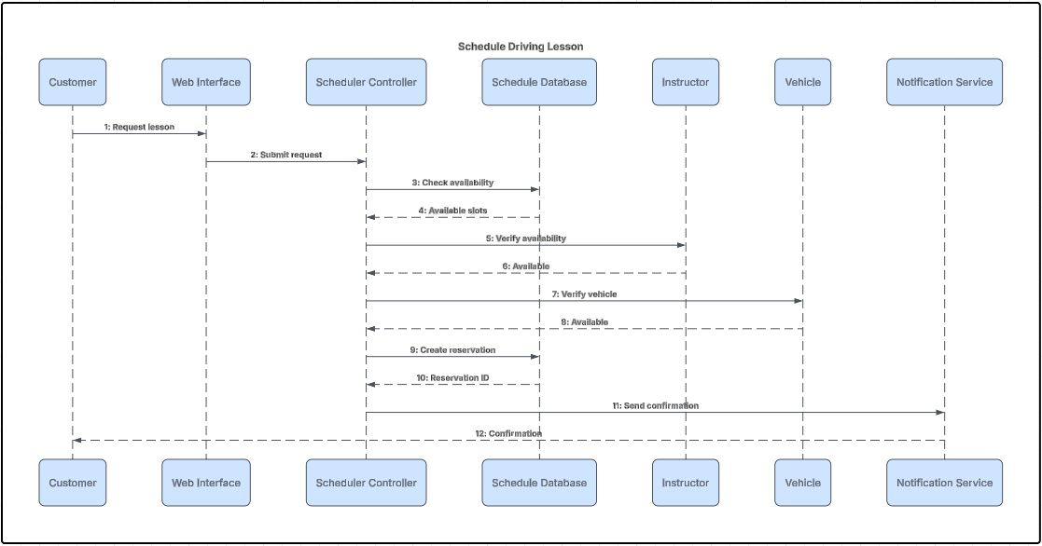

UML Class Diagram
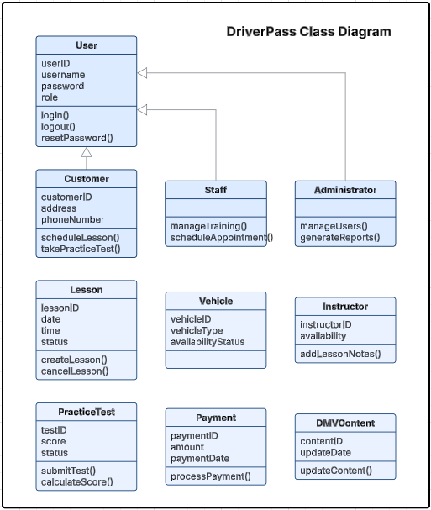

Technical Requirements
Based on the diagrams created for the DriverPass system, several technical requirements are needed to support the system's functionality. The system should be a cloud-based web application that allows customers, staff, and administrators to access it through a web browser on desktop and mobile devices. This approach ensures users can schedule lessons, take practice tests, manage accounts, and access training information from any location with an internet connection.
From a hardware and infrastructure perspective, the system requires cloud-hosted servers to run the application, store user data, and maintain high availability. A database server is also necessary to store customer accounts, lesson schedules, training records, practice test results, payment information, and DMV content updates. In addition, backup and recovery services should be implemented to protect data and ensure business continuity in the event of a system failure.
The software requirements include a relational database management system, a web application framework, and secure authentication services. The system must support role-based access control so that customers, staff, and administrators can only access the features appropriate to their roles. Secure HTTPS communication using SSL/TLS encryption is also required to protect sensitive information as it is exchanged between users and the system.
The diagrams also show the need for integration with external systems. The DriverPass system must connect to a payment processing system to handle customer payments and a DMV information system to receive updated driving regulations and practice test content. These integrations ensure that users have access to current information and can complete transactions securely.
Finally, developers will need tools such as UML modeling software, an integrated development environment (IDE), testing tools, and version control software to design, build, and maintain the application. Together, these hardware, software, and infrastructure requirements provide the foundation needed to support the scheduling, training, testing, and administrative functions identified in the DriverPass system design.

